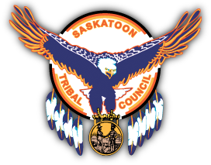



Saskatoon Tribal Council Communities Lead in Traffic Safety Improvements

**TRAFFIC SAFETY**

**2021-2022 TRAFFIC SAFETY PROJECTS**

Report by Michael Henricks, Traffic Safety Coordinator, Saskatoon Tribal Council and Stephanie Sunshine Saskatoon Tribal Council Justice Summer Student. In partnership with Tracy Church, Traffic Safety Liasson SGI.

We are so close to having Covid restrictions lifted for Saskatchewan and Canada! Summer is finally here and it is a hot one! Drink lots of fluids, stay hydrated, wear sunscreen and stay in the shade to keep cool! While you are keeping cool, the Saskatoon Tribal Council and SGI would like to congratulate three of our communities for having their SGI grants and projects approved by SGI. Congratulations to One Arrow First Nation, Muskoday First Nation and Kinistin First Nation on your traffic safety projects. Here is each of the three communities and their traffic safety project.

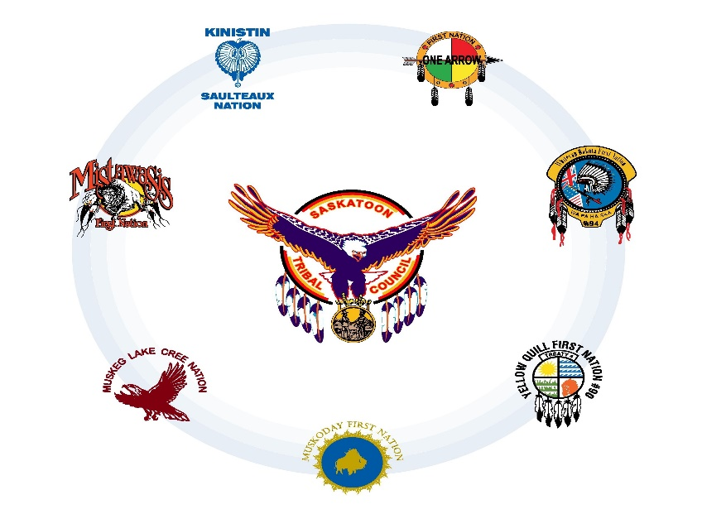



Provincial Traffic Safety Fund Grant Recipients

January – March 2021

|  |  |  |
| --- | --- | --- |
| Applicant | Project | Amount Approved |
| Town of Aberdeen | Traffic Calming | $ 17,068.00 |
| RM of Aberdeen | Speed Radar – Safe Signs | 10,500.00 |
| Town of Alameda | Speed Management | 4,213.00 |
| Village of Archerwill | Solar-Powered Speed Sign | 3,350.00 |
| RM of Arlington | Signing – TWP/RGE Road Signs | 17,646.00 |
| Town of Assiniboia | Pedestrian Safety | 20,000.00 |
| Town of Balcarres | Be Safe Balcarres | 19,939.00 |
| Beardy’s & Okemasis First Nation | Highway 212 Speed Management | 8,382.00 |
| Northern Village of Beauval | Speed Management and Pedestrian Safety | 7,000.00 |
| Village of Belle Plaine | Speed Management | 3,568.00 |
| Town of Bienfait | Highway 18 Pedestrian Crossing Safety | 5,783.00 |
| Town of Big River | Sidewalk for Pedestrian Safety | 47,005.00 |
| Town of Biggar | School Zone and Playground Safety Initiative | 32,653.00 |
| Town of Blaine Lake | Speed Control and Safety 2021 | 11,689.00 |
| Village of Borden | 2nd Avenue Slow Down | 7,613.00 |
| Village of Brownlee | Speed Awareness | 8,500.00 |
| Resort Village of Candle Lake | Main Street Traffic Calming and Pedestrian Safety | 22,893.00 |
| RM of Canwood | Mont Nebo Speed Management | 3,493.00 |
| Hilldrop Highspeed Control Management | 6,985.00 |
| Highway 55 Speed Management | 6,985.00 |
| Town of Carlyle | Traffic Calming Project | 18,160.00 |
| Town of Central Butte | Vehicle Speed Management | 8,600.00 |
| Resort Village of Chitek Lake | Pedestrian Safety Walkway | 50,000.00 |
| Village of Craven | Crosswalk Lights for Fraser and Hwy 20 | 9,680.00 |
| Village of Debden | School Zone Speed Awareness and Safety | 3,973.00 |
| Town of Eastend | Flashing Crosswalk Sign Project | 7,098.00 |
| City of Estevan | King Street & 13th Avenue Traffic Safety Upgrade | 40,000.00 |
| Town of Eston | Speed Display Signs | 3,213.00 |
| Flashing/Lighted Cross Walk Signage | 4,200.00 |
| RM of Excel | Speed Radar Signs for Hamlets | 13,731.00 |
| RM of Frenchman Butte | Work/Construction Zone Safety | 9,250.00 |
| George Gordon First Nation | Slow Vehicles Down | 7,682.00 |
| Resort Village of Glen Harbour | Slower is Safer | 4,085.00 |
| Town of Govan | Speed Management Project | 6,426.00 |

|  |  |  |
| --- | --- | --- |
| Applicant | Project | Amount Approved |
| Resort Village of Grandview Beach | Beach Road Solar Speed Signs | $ 8,425.00 |
| Village of Grayson | Speed Management | 10,940.00 |
| RM of Griffin | Light Up the Hamlets | 17,444.00 |
| Town of Gull Lake | Keeping our Community Safe | 47,438.00 |
| Town of Hanley | Streetlight for Pedestrian Safety | 3,689.00 |
| Village of Harris | Radar Speed Control | 6,700.00 |
| RM of Hoodoo | Lakeside Speed Monitoring | 7,035.00 |
| City of Humboldt | Traffic Signal Audible Push Buttons | 9,450.00 |
| Town of Imperial | Know Your Speed | 3,463.00 |
| RM of Indian Head | Digital Speed Signs | 4,213.00 |
| RM of Invergordon | Crystal Springs Speed Management | 7,570.00 |
| Village of Invermay | Highway 5 Speed Management | 6,385.00 |
| Town of Ituna | Traffic Calming Initiative 2021 | 15,351.00 |
| Resort Village of Kannata Valley | Speed Bumps | 9,976.00 |
| District of Katepwa | Pedestrian Safety and Speed Awareness | 9,114.00 |
| Village of Killaly | Killaly Community Safety Initiative 2021 | 17,105.00 |
| Kinistin Saulteaux Nation | "Bay ah tuck" – Slow Down | 11,522.00 |
| Lac La Ronge Indian Band | Sucker River Speed Management Initiative | 7,180.00 |
| Town of Lafleche | School Zone Speed Awareness and Pedestrian Crossing | 19,805.00 |
| RM of Lakeside | Binsaurer Road Speed Management | 3,075.00 |
| Town of Langenburg | Reduce Speeds/Injuries – Safe Active Travel Plan | 7,676.00 |
| Village of Lintlaw | Slow & Safe | 7,000.00 |
| RM of Loreburn | Radar Speed Sign for Community Safety | 4,000.00 |
| Village of MacNutt | Speed Bumps Project | 1,959.00 |
| Town of Maidstone | Speed Observance | 6,700.00 |
| Resort Village of Manitou Beach | Safety Signage for Speed Management | 400.00 |
| Town of Maple Creek | Speed Signs | 7,035.00 |
| Town of Marshall | Intersection Safety | 9,399.00 |
| City of Meadow Lake | Pedestrian Safety | 20,042.00 |
| Flying Dust First Nation (Meadow Lake Tribal Council) | Slow Down for Pedestrians | 10,422.00 |
| Village of Meath Park | School Crosswalk Pedestrian Safety | 10,000.00 |
| Town of Milestone | Speed Safety Within our High-Risk Community Areas | 15,795.00 |
| Village of Montmartre | Speed Awareness and Management | 7,623.00 |
| Village of Muenster | Muenster Traffic Radar Signs 2021 Project | 11,631.00 |
| Muskoday First Nation | Walkway for Pedestrian Safety | 19,805.00 |
| Town of Nipawin | Sidewalk Extension Along Highway 35 South | 50,000.00 |
| Town of Nokomis | Speed Reduction Initiative | 9,010.00 |
| City of North Battleford | Preemptive Warning Signal Lights | 68,909.00 |
| RM of North Qu'Appelle | Pasqua Lake Road Speed Reduction Strategy | 16,753.00 |
| One Arrow First Nation | Lighting our Future to Decreased Traffic Accidents/Violations | 19,497.00 |

[www.sgi.sk.ca](http://www.sgi.sk.ca/)

|  |  |  |
| --- | --- | --- |
| Applicant | Project | Amount Approved |
| Piapot First Nation | Piapot First Nation Traffic Safety Initiative | $ 19,743.00 |
| Town of Pilot Butte | Walk a Butte - Phase II | 7,437.00 |
| RM of Pinto Creek | Meyronne Solar Speed Radar Signs | 6,781.00 |
| RM of Pleasantdale | Speed Display System | 7,035.00 |
| RM of Ponass Lake | Sight Line Safety Project | 10,175.00 |
| Town of Ponteix | Speed Management | 16,851.00 |
| Town of Porcupine Plain | Speed Management | 8,135.00 |
| City of Prince Albert | Pedestrian Intersection Improvements | 27,560.00 |
| Village of Quill Lake | Traffic Management | 4,613.00 |
| Quill Highway 5 Speed Control | 8,426.00 |
| City of Regina | Rapid Rectangular Flashing Beacons in School Zones | 23,021.00 |
| Town of Rocanville | Radar Speed Sign | 6,426.00 |
| Town of Rosetown | Highway 4 Speed Signs | 14,874.00 |
| Town of Rosthern | Speed Reduction | 7,322.00 |
| Town of Saltcoats | Saltcoats Safety Speed Control | 6,157.00 |
| City of Saskatoon | McKercher Drive & Edinburgh Place Active Pedestrian Corridor | 17,893.00 |
| RM of Sasman | North Shore Traffic Safety Initiative | 6,426.00 |
| Town of Shaunavon | 3rd Avenue Crosswalk | 6,532.00 |
| Village of Shell Lake | Speed Management | 7,000.00 |
| Town of Shellbrook | Speed Sign Initiative | 17,500.00 |
| RM of Shellbrook | Speed Management | 7,675.00 |
| Village of Silton | Speed Management | 4,466.00 |
| Resort Village of South Lake | Speed Awareness | 8,848.00 |
| Town of St. Brieux | Barbier Children Crossing Speed Control Zone Area | 4,250.00 |
| Village of Success | Speed Management and Awareness | 2,810.00 |
| Resort Village of Sunset Cove | Sunset Cove Community Safety Program | 7,501.00 |
| Sweetgrass First Nation | Sweetgrass First Nation Speed Signs – Highway 40 West | 7,500.00 |
| City of Swift Current | Pedestrian Crossing Enhancements | 49,000.00 |
| RM of Three Lakes | Community Safety in Speed Management | 4,000.00 |
| Village of Tugaske | Traffic Safety Improvements | 8,426.00 |
| Village of Vanguard | Pedestrian Crosswalk Project | 7,643.00 |
| RM of Victory | Demaine Slow Traffic Down | 2,469.00 |
| RM of Viscount | Construction Zone Speed Radar Signs | 9,731.00 |
| Village of Waldeck | Speed Reader Sign for Safety | 3,350.00 |
| City of Weyburn | Pedestrian Safety Initiative | 26,669.00 |
| Town of White City | The Gregory Avenue East Pedestrian Crosswalk – Safety Improvement | 21,705.00 |
| RM of Winslow | TWP 330 Range Road 3193 Intersection | 10,356.00 |
| Town of Zealandia | Speed Bump Safety | 2,795.00 |
| Total funding | | $ 1,400,000.00 |

2

**KINISTIN SAULTEAUX NATION**



“This past winter the KSN justice department sent out an online survey to KSN community members and staff to complete, this survey helped me to determine that speed management and aggressive driving was the main concern expressed. With the received information, I on the behalf of the community’s concerns applied for 3 sonar speed radar signs to be installed at each of the entry points to remind drivers accessing the community to slow down. The project’s name is “Bay Ah Tuck” – Slow Down, which means slow down in the community’s language. The justice department and Kinistin Saulteaux Nation are very appreciative to the Photo Speed Enforcement Committee and SGI for approving our grant application the “Bay Ah Tuck” – Slow down project. Thank you and stay safe out there.” – Andrea Gervais. Justice Reintegration Worker, Kinistin Saulteaux Nation.

Kinistin Saulteaux First Nation got approved for a grant from SGI for $11,522.00 for a speed management sign. Congratulations Kinistin!



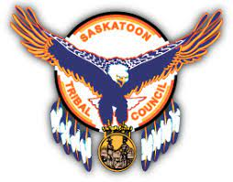

## ONE ARROW FIRST NATION

## One Arrow First Nation received a Provincial Traffic Safety Grant of $19,497.00 from SGI. This grant will help One Arrow First Nation build infrastructure on the reserve to support traffic safety within their community. This will ensure safe driving, and pedestrian safety as well within their community. Congratulation One Arrow First Nation on receiving the Provincial Traffic Safety Grant from SGI.

“On June 28th last month, I was in Melfort attending court. I had gotten a text message from SGI'S Tracy Church informing me the 2021 SGI Traffic Safety Grant awarded recipients' list had included One Arrow First Nation's "Lighting Our Way to Decreased Accidents/Traffic Violations" project had been approved. This grant is close to $20,000 to purchase Solar Lights. I was really very elated. In 2020, Mike Henricks and Tracy Church had a first initial meeting with me regarding the possibility of One Arrow First Nation applying for this grant. I was interested of course and somewhat intimidated by the thickness of the application itself. Mike had suggested that One Arrow First Nation apply for the Grant consecutively for 5 years so that we may think of projects that coincide with each other. This plan had made the process of designing a project so much more easier. In 2020, we were approved for 2 digital speeding signs and this year we were approved for the Solar Lighting. The year 3 project has not been decided as of yet. I am profoundly thankful to Mike and Tracy. Without their knowledge and expertise in their professional fields and their patience - as I am computer illiterate, I would not have even attempted to apply for such a grant as it was intimidating in the very beginning. I now have confidence regarding this Grant, with all the many steps within it, thanks to Mike Henricks and Tracy Church. We, as STC Community Justice Workers - have really great resources (Crystal Laplante, Mike, Tracy, ect.). We are not left alone to fend for ourselves regarding our Justice Programs. We all strive to help make our communities safe for the People and it is just feels so good knowing we all share a common goal of Community Wellness and Safety.”

Crystal Sutherland

One Arrow First Nation

## 

## 

## MUSKODAY FIRST NATION

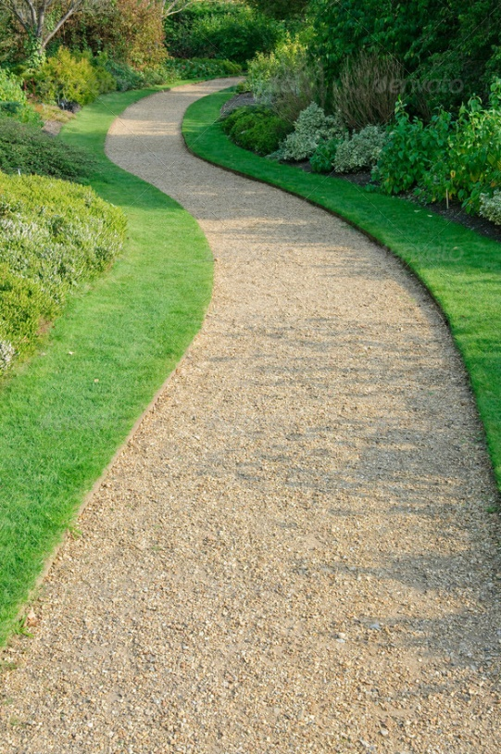 “I would like to express a huge thank you to Tracy Church from SGI and Mike Henricks from STC for making this possible.

I have never applied for this grant in the past as I felt overwhelmed. Tracy was the positive influencer and whom helped me overcome the fears of this huge funding application. Tracy walked me through each step. Mike helped with the community surveys.

Over the last ten years or so we as a community have witnessed deaths as it relates to fatal collisions and many injuries related to collisions along our highway #3. There has been talks as well over the years as to what we can do to help reduce these stats. I put out a survey to our band members and the response was overwhelming. The members wanted a walkway from the bridge to the store. They wanted it for recreation, to provide safety and peace of mind. Our community will access this pathway to get to our only store.

I am honoured to have been chosen as a community for this grant. It is a huge benefit to all.” Cori Pederson, Muskoday Justice Coordinator.

Muskoday received a $19,805.00 grant from SGI called the Provincial Traffic Safety Fund Grant. Muskoday First Nation was in high need for a pathway so that pedestrians could get safely from the bridge to the store. With this grant, the reserve will have their pathway which creates safety for everyone in the community that will be utilizing the pathway. Congratulations Muskoday!

## 

## 

**Yellow Quill First Nation**

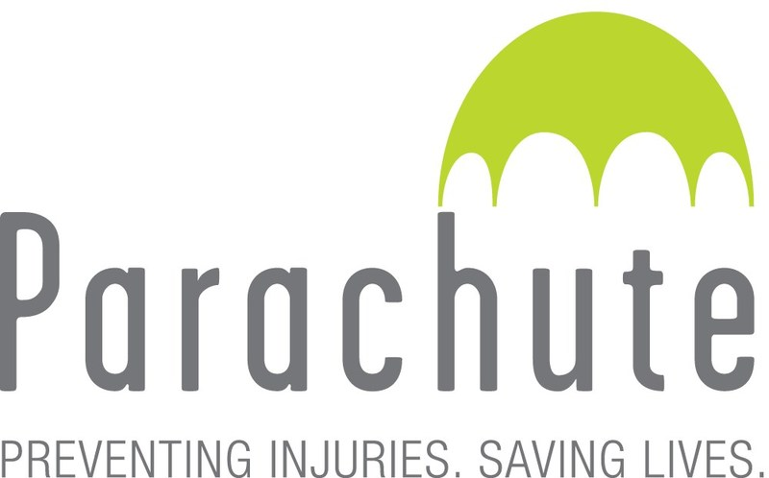Yellow Quill First Nation was selected for the 10,000.00 Parachute program. The grant is a three-year traffic safety initiative promoting traffic safety for the school and the community. Congratulations Yellow Quill First Nation for being selected for this program





Please reach out to Mike Henricks, [mhenricks@sktc.sk.ca](mailto:mhenricks@sktc.sk.ca) for support or questions on traffic safety initiatives with STC communities

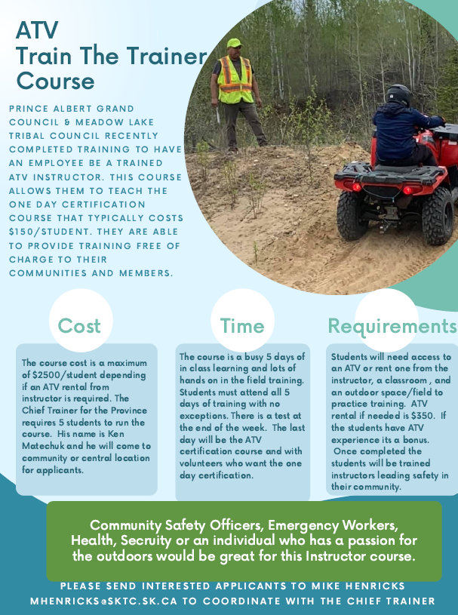

An ATV Train the Trainer Course through Ken Matechuk and SGI. The 5-day intense training course covers all the aspects of ATV training. People interested in the course should have a keen interest and some knowledge with ATVs. **Please be aware that there is a $2500.00/person to attend and complete the course. If you require an ATV Ken will provide one for you for $350.00. We will need a minimum of five people to attend this course.** If you have any questions, please contact me at your earliest convenience.

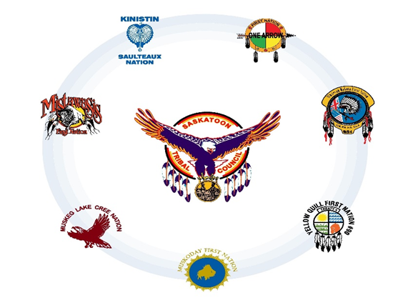

Thank you,

**Michael Henricks**

Traffic Safety Coordinator

Saskatoon Tribal Council

2211 11th Street West

Saskatoon, SK. S7M 1J4

306-381-3414

[mhenricks@sktc.sk.ca](mailto:mhenricks@sktc.sk.ca)

SGI's Traffic Safety Community Outreach team works hard to support the goal of Saskatchewan having the safest roads in Canada. Community Outreach team members work with communities and organizations across Saskatchewan to identify traffic safety issues, support existing programs, and develop new programs that encourage positive driving behaviours. Please reach out if you would like Traffic Safety Community Outreach's help to support your community on traffic safety initiatives:

**GRANTS & PARTNERS**

Email: [trafficsafety@sgi.sk.ca](mailto:trafficsafety@sgi.sk.ca)

Phone: 1-8444-855-2744 extension 6042

### Provincial Traffic Safety Fund

The Provincial Traffic Safety Fund is provided by the Government of Saskatchewan and administered by SGI. The program provides up to $100,000 (per location) to municipalities and Indigenous land or territories. The goal of this fund is to stimulate and support local, collaborative action that will increase traffic safety awareness and reduce the frequency and severity of traffic injuries and fatalities within Saskatchewan. The grant opens to request project numbers January 1st & July 1st with applications due March 31st & September 31.

email [PSEProgram@sgi.sk.ca](mailto:PSEProgram@sgi.sk.ca) to request guidelines.

**Applications Due: March 31st & September 30th**

### Child Passenger Safety Grant

SGI and the Saskatchewan Prevention Institute partner to help groups in need buy car seats. The maximum amount in one calendar year is $2,500 per organization.

**Applications Due the last Wednesday in February, May, August, November**

### Community Grant: Acquired Brain Injury & SGI

The program provides $100,000 a year in total grants to help local organizations offset the cost of traffic safety and brain injury prevention programs. The average grant amount is $1,000 per project. The grant program is looking for submissions in the following areas impaired driving, pedestrian safety, bicycle safety, snowmobile

and ATV safety,

**Applications Due: October 31st & February 28th**

# GRANTS & PARTNERS

ABI Outreach Support Teams supports schools and community as well as referrals from health facilities, physicians, rehabilitation program, and professional support services.

You can contact an ABI Outreach Support Team by calling:

Saskatchewan North: (306) 765-6630

Saskatchewan Central: (306) 655-7743

Saskatchewan South: (306) 766-5617

Plan a Brain Walk to help students from kindergarten to grade six learn about the different functions of the brain and preventing brain injury.

Plan a Brain Waves presentation for students in Grades 4-6 to learn about the importance of the brain as well as preventing brain and spinal cord injuries.

Plan a PARTY for Students in grades 10-12. Students will learn the risk of alcohol by visiting a hospital and experience what it would be like to be a trauma patient. What brought you here, what kind of medical intervention and care will you need and what will life look like once, or if you are discharged?

Plan an ATV or snowmobile presentation related to helmet use and injury prevention.

*Brain Waves & PARTY can be delivered virtually as well



# GRANTS & PARTNERS

The Saskatchewan Prevention Institute is a non-profit organization, founded in 1980. Their focus is to reduce the occurrence of disabling conditions in children using primary prevention methods. We raise awareness by providing training, information, and resources based on current best evidence.

The Saskatchewan Prevention Institute believes that children of all abilities have the right to the best physical, social, and emotional health possible.

Saskatchewan Prevention Institute are leaders in safety. Specific to traffic safety are the following topics:

Child Passenger Safety: to book a presentation, host a car seat clinic Bicycle Safety: to book a Bike Rodeo & teaching resources.

ATV Safety: online presentation and information. Pedestrian Safety: online information Alcohol/FASD: online information

Sask Prevention Institute have been a valued partner for child passenger safety and bike safety in our communities.

Visit [www.skprevention.ca](http://www.skprevention.ca/)

For a full list of free resources and programs available

